# Shell Script- Assignment

**Mandatory:**

1. **Create a script named “myscript” in current directory to do the following.**
2. **display “hello user”**

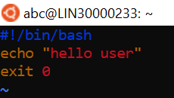

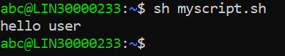

1. **list files in current directory**



1. **name of logged in user**

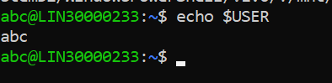

1. **date**

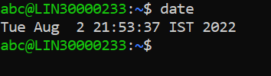

1. **Add execute permission and Run the script from**
2. **current directory**

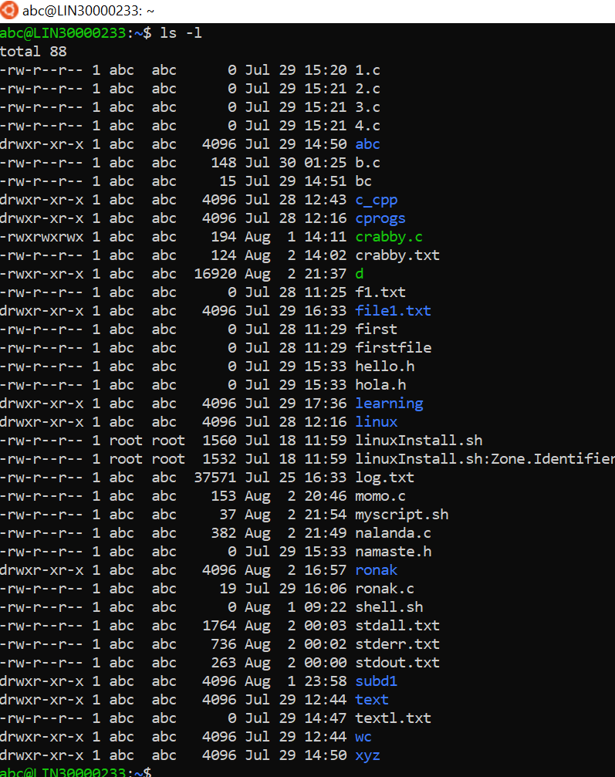

1. **Create a subdirectory named “test”**

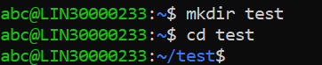

1. **Change to “test” directory. Run the script “myscript” [Hint: You will have to update PATH to include the directory containg script to run script from any location].**

Ans:

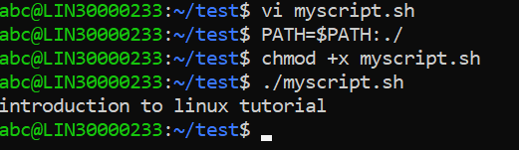

**Optional Assignments:**

1. Considering command line arguments are accessible using $<position> i.e

$0- for first argument

$1- for second argument…

write a shell script to concatenate all command line arguments using ‘_’ and display it as a single string.

Refer example below

$>./myscript.sh ABC DEF

Output:

ABC_DEF

[Refer <http://linuxcommand.org/lc3_wss0120.php>]

Ans

